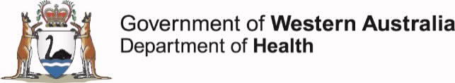
Novel Coronavirus (COVID-19) Update
Dear parents and students
Updated Advice from the Chief Health Officer
Schools have now been open for students since the commencement of Term 2 and I am very encouraged by the way the school community, parents and students are caring for their health and attending school in a responsible way. This is building community confidence in the safety of our schools with the overall attendance rate reaching over 82%.
WA recently recorded 14 days with only 2 reported cases, both of whom were rapidly identified and are in isolation. With over 56,000 negative tests and only 7 active cases, there is no evidence of community transmission.
The WA State Government has recently announced further decisions about the easing of restrictions in our state as part of a phased approach in the management of the pandemic. These decisions have been based on public health advice and will continue to be carefully monitored in the weeks ahead.
Public health measures already in place to protect the community will remain a focus during this time, including broad testing, comprehensive contract tracing when a case is identified, isolation and quarantine measures where required, and education about social distancing and hand hygiene. Plans remain in place to ensure immediate response to any reported infections in the school setting when needed to prevent the spread of any illness.
I continue to recommend that schools should remain open to all students and families should be encouraged to return their children to the classroom. If your child is more vulnerable due to health problems or your have a vulnerable adult living in your home, then I would recommend seeking advice from your specialist medical practitioner as to whether returning to school remains the best option for you.
We need to remain diligent during this time and I encourage you to please make sure you keep your child home if they are unwell and, if you or your child have fever, cough or cold symptoms, get tested for COVID-19. We should all continue to follow the social distancing guidelines when interacting with other parents, teachers and school staff.
Thank you again for your leadership and support during this challenging time.
Yours sincerely
DR ANDY ROBERTSON
Chief Health Officer
May 2020

